**Create VNet/VPC peering between 2 different regions:**

**Azure (Azure Virtual Network Peering):**

1.Create two resource groups (RG1/RG2) with Two different cross regions.

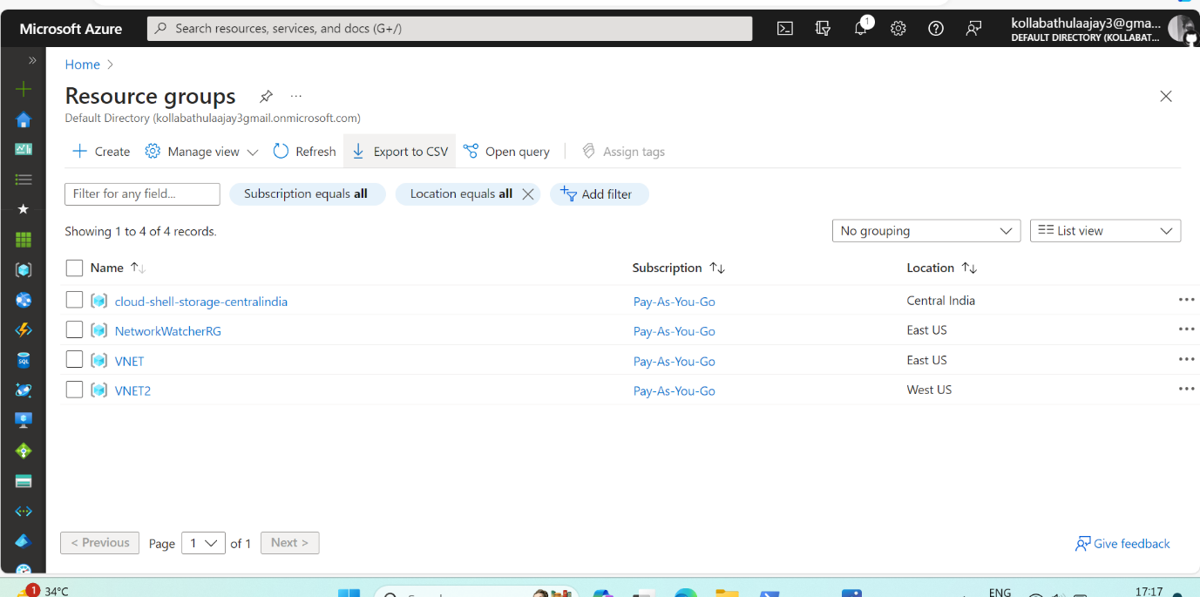

2.Create two VNETS (VN1-RG1/VN2-RG2) with same cross regions as you selected before in resource groups. And created subnets for both

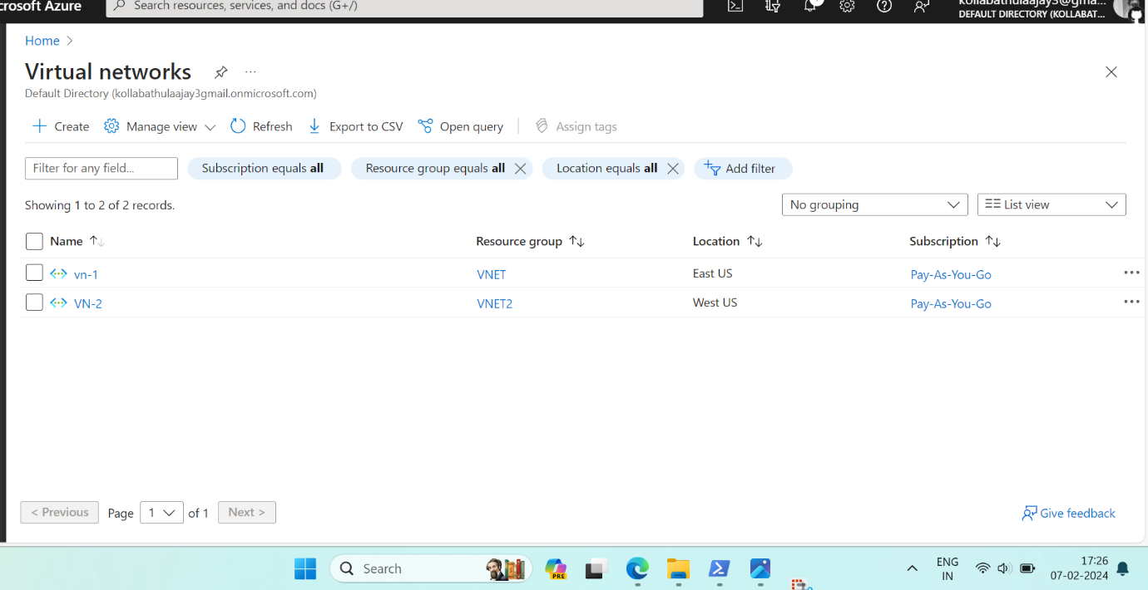

3.Create two virtual machines with **(**VM1-VN1/2- VN2) with same cross as you created before in virtual Networks

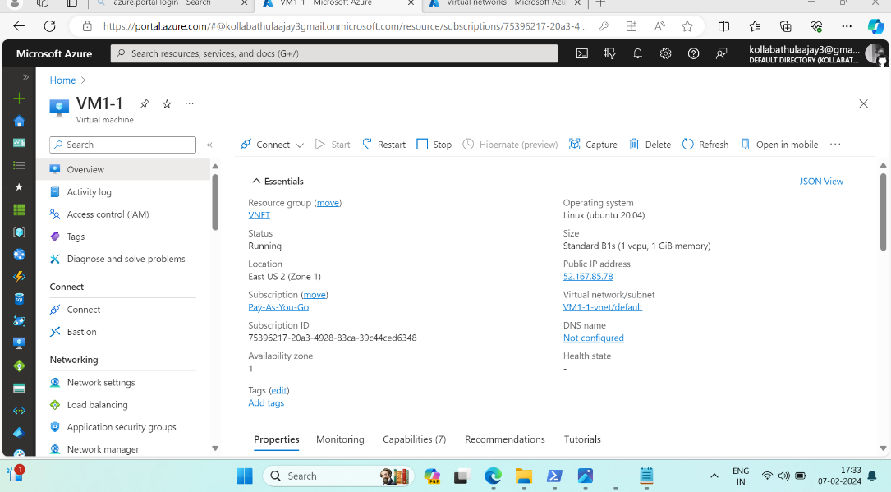created Virtual Machine-1

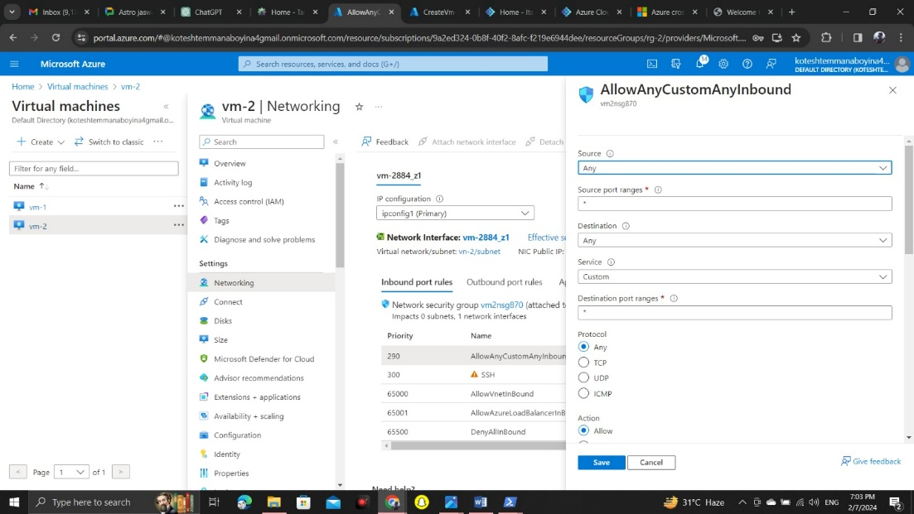Created second Virtual Machine-2

GO to PowerShell and Login with public Ip address with VM-1

Sudo apt install NGINX

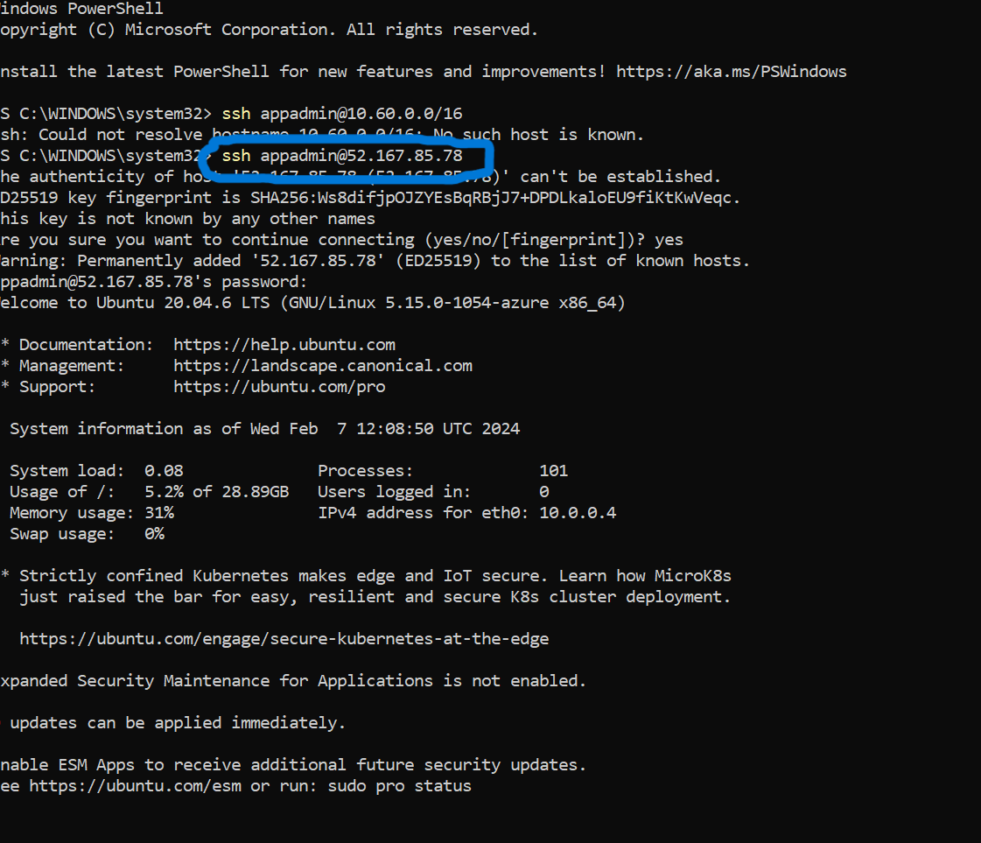

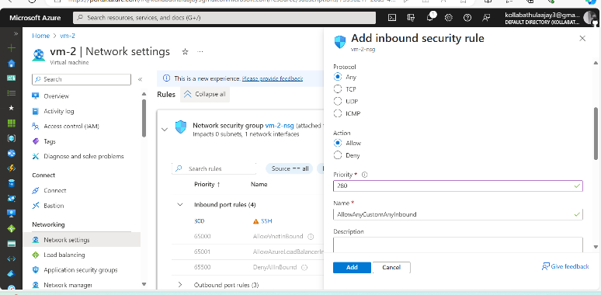

NETWORK SETTINGS

VM -Network settings changed inbound security rule then permissions accessed from traffic successful runed NGINX

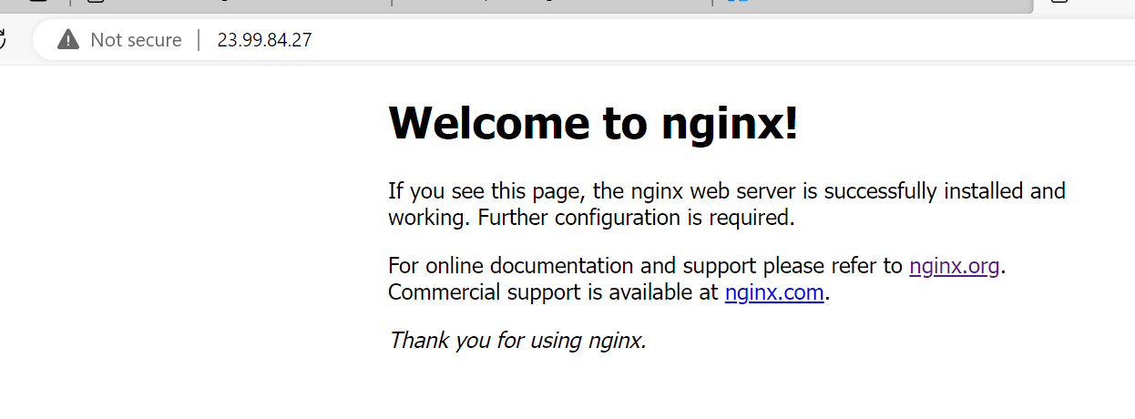

**PEERING**

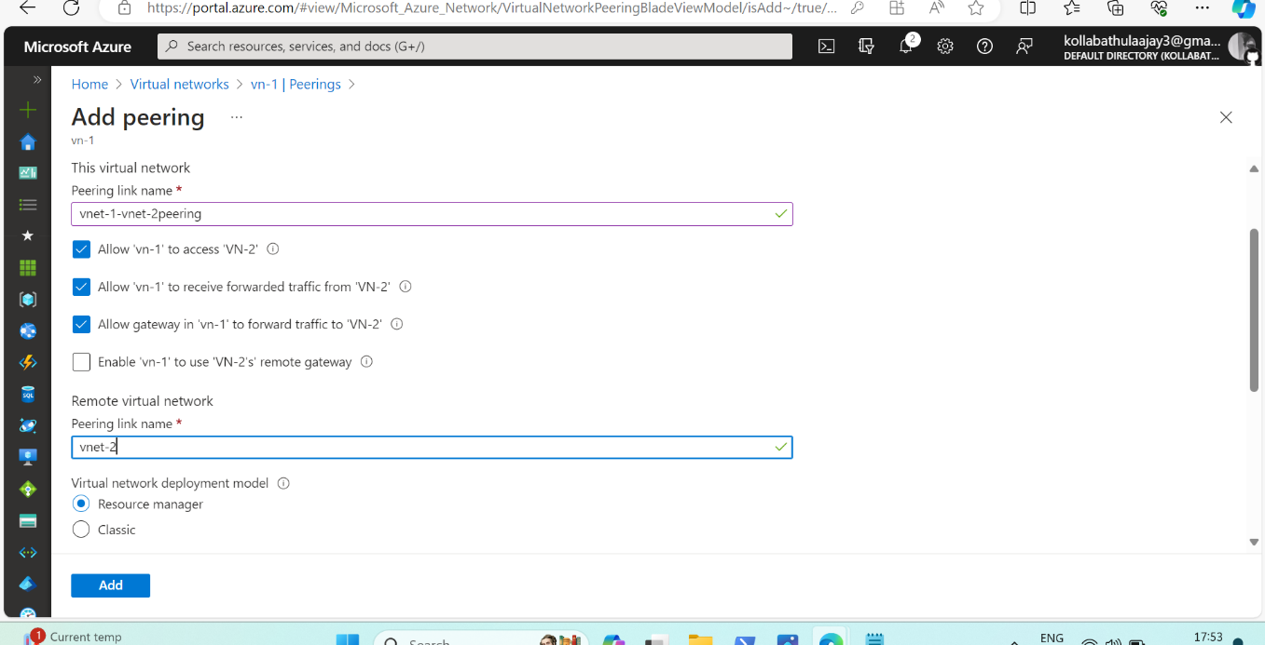

Peering for vnet-1 to access vnet-2 virtual network and accept the peering request

After peering is established, verified connection between resources in the peered networks.

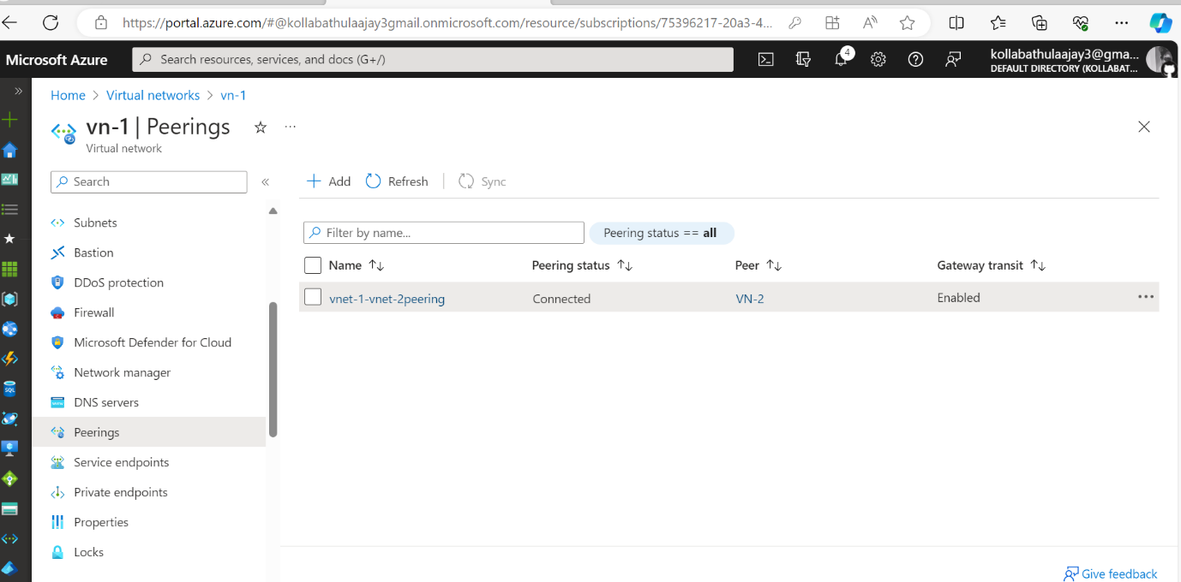

Back to PowerShell and Ping another Ip address

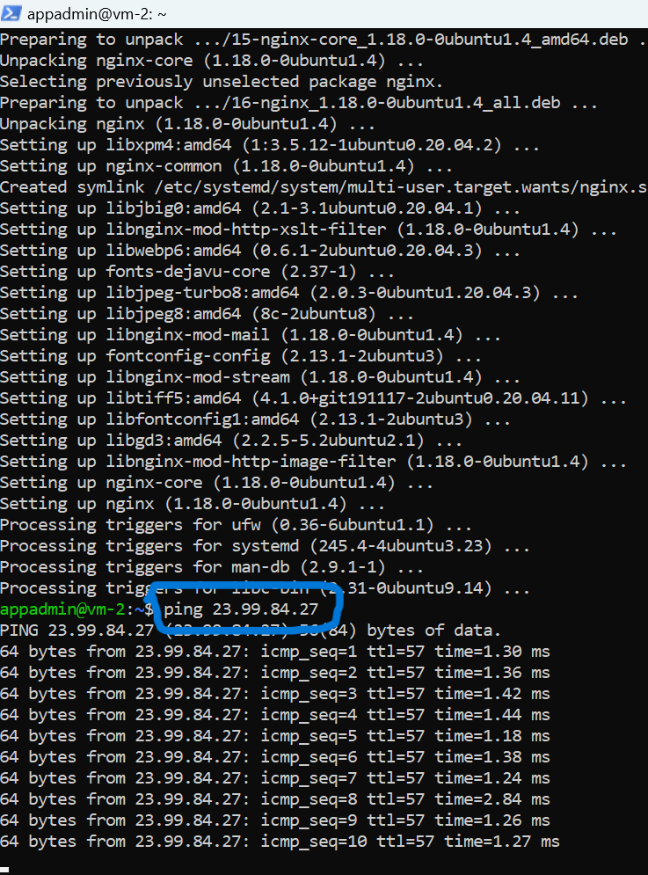

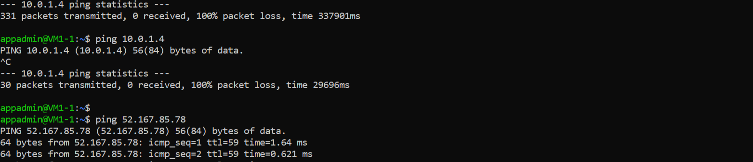

Runed with another IP Address

